AIRPORT MANAGEMENT SYSTEM

Project Report

Submitted By
Dakshal Srivastava
Registration Number: 24BSA10115

Introduction

Project Overview
The Airport Management System is a backend-based application developed to automate and manage essential airport operations efficiently. The system integrates a Node.js and Express.js REST API with a MongoDB database, providing centralized management of flights, passengers, staff records, bookings, payments, and in-flight services.
The project offers two distinct interfaces:
- Interactive Command-Line Interface (CLI) – A menu-driven terminal application that allows users to perform CRUD operations through an intuitive console interface.
- Swagger UI Interface – A browser-based API testing environment that enables developers and users to interact with the system through documented REST endpoints.
The application demonstrates practical implementation of backend development concepts, database management, API design, schema validation, automation triggers, and business logic enforcement.

Problem Statement
Airports handle large volumes of operational data including flights, passengers, bookings, staff assignments, payments, and customer services. Manual management of these processes can result in:
- Data inconsistency
- Booking errors
- Incorrect seat allocations
- Duplicate passenger records
- Payment inaccuracies
- Poor service customization management
Therefore, an automated system is required to streamline operations while maintaining data integrity and operational efficiency.

Objectives
The primary objectives of the Airport Management System are:
- To manage flight information through complete CRUD operations.
- To maintain passenger records with proper validation.
- To manage airport staff and departmental assignments.
- To automate booking and seat allocation processes.
- To automate payment generation and pricing calculations.
- To provide customizable in-flight services.
- To expose RESTful APIs for easy integration and testing.
- To offer both CLI-based and browser-based user interaction.

Output Screenshots
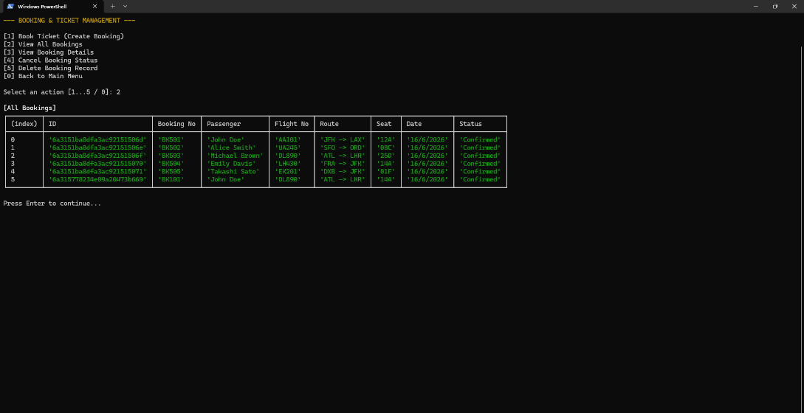
Console – GET Bookings
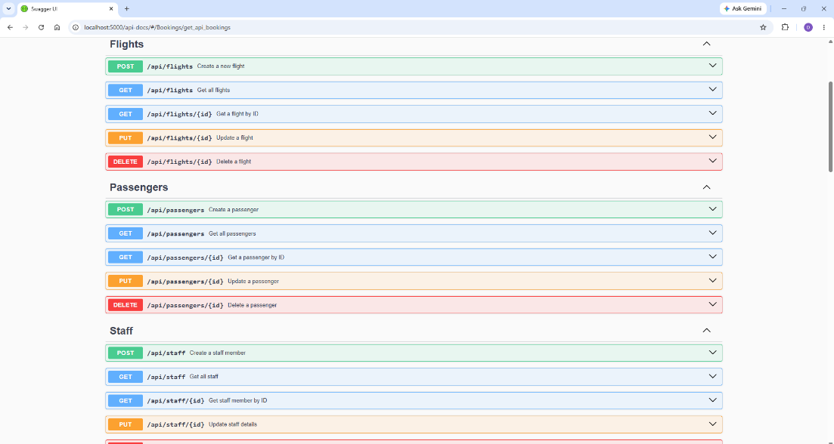
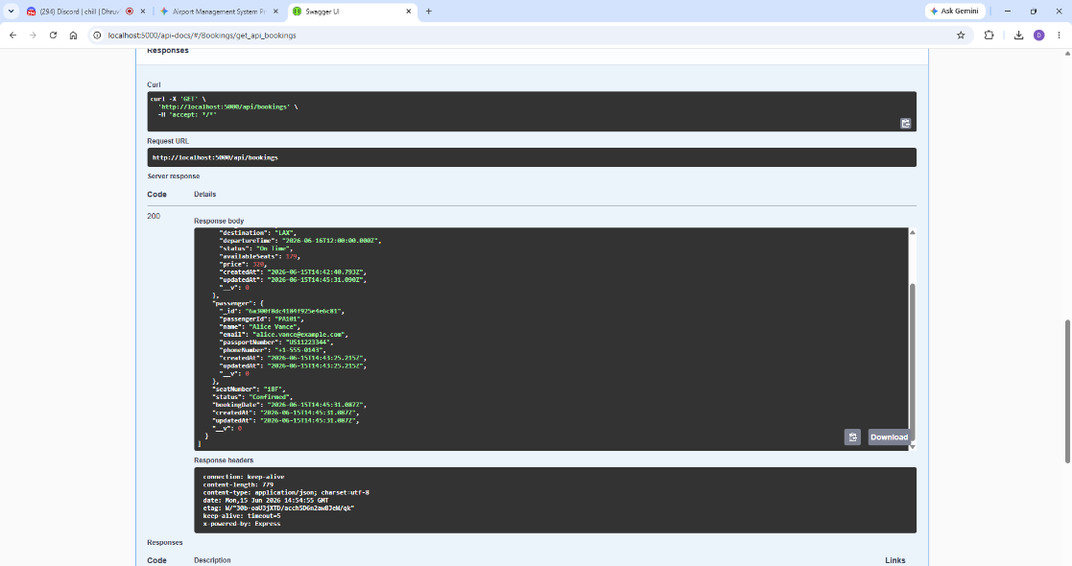
Swagger UI
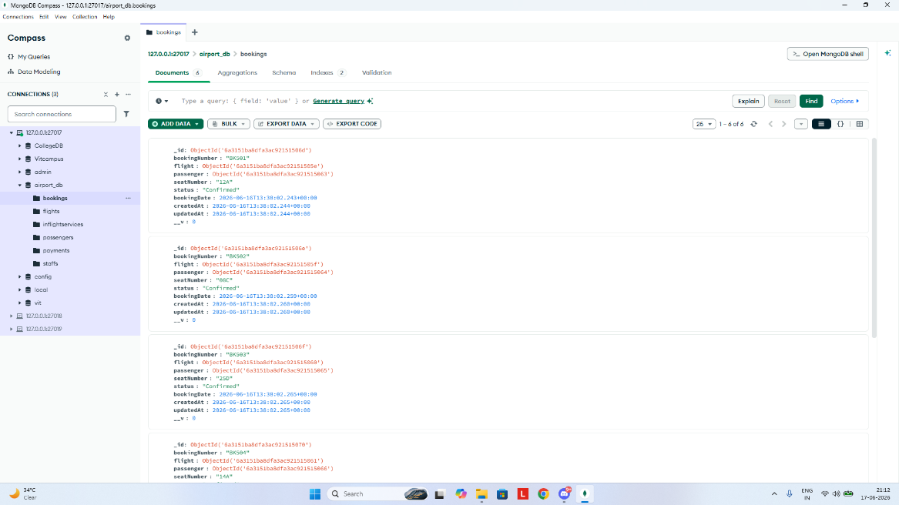
MongoDB – Bookings
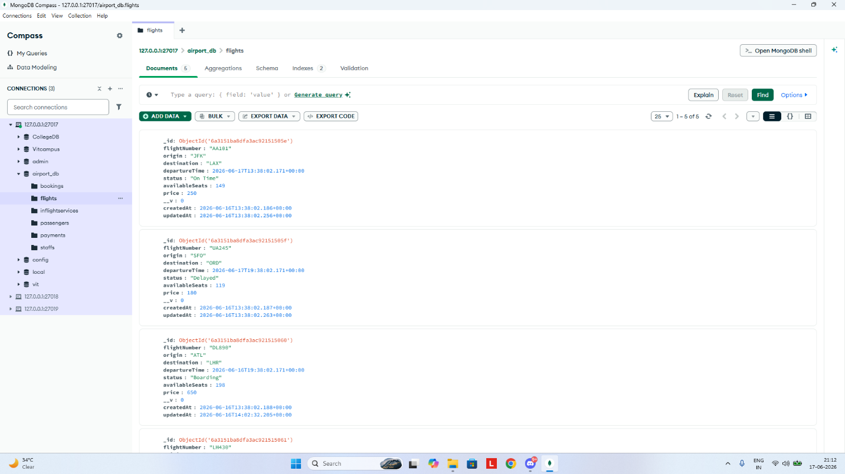
MongoDB - Flights
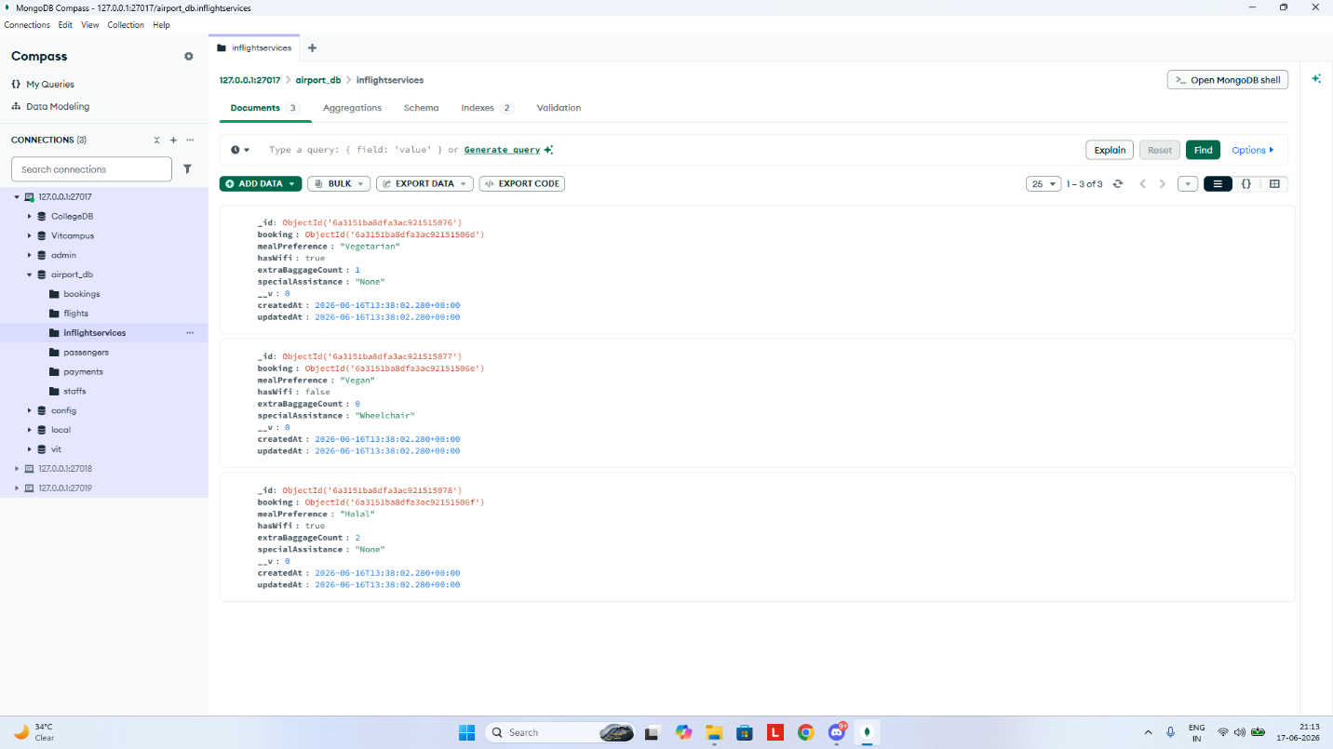
MongoDB - Services

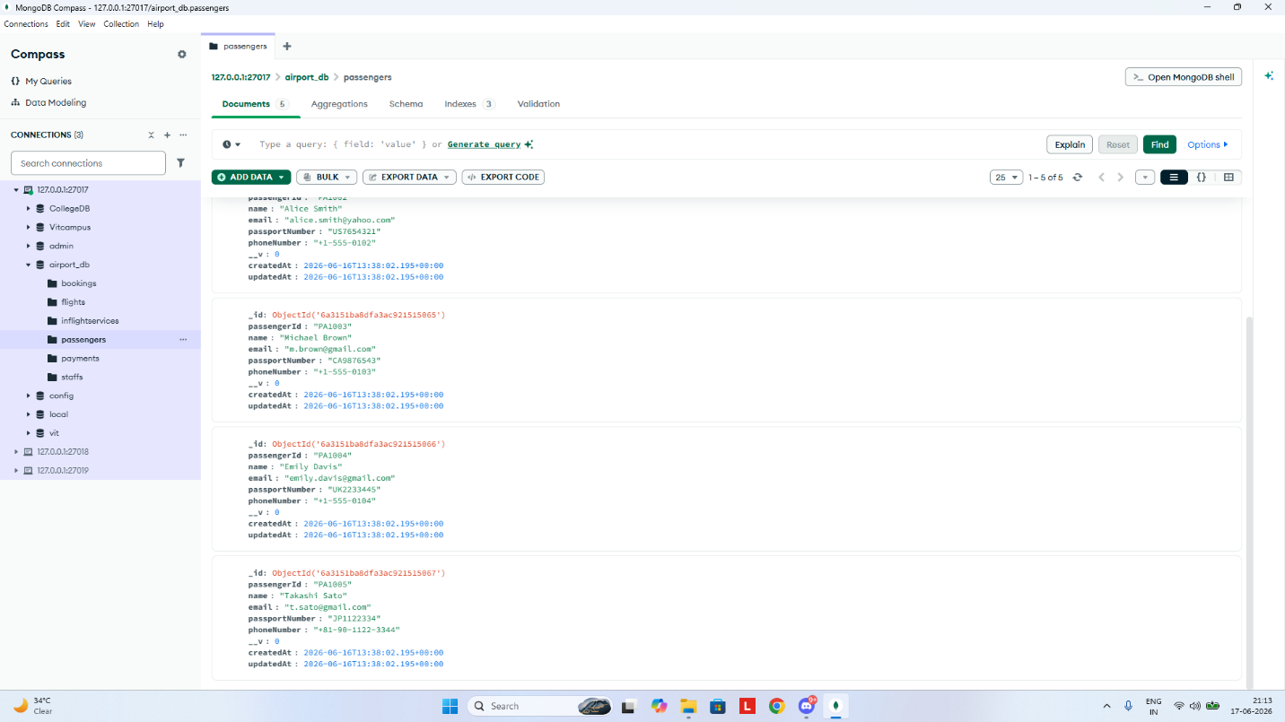
MongoDB – Passengers.
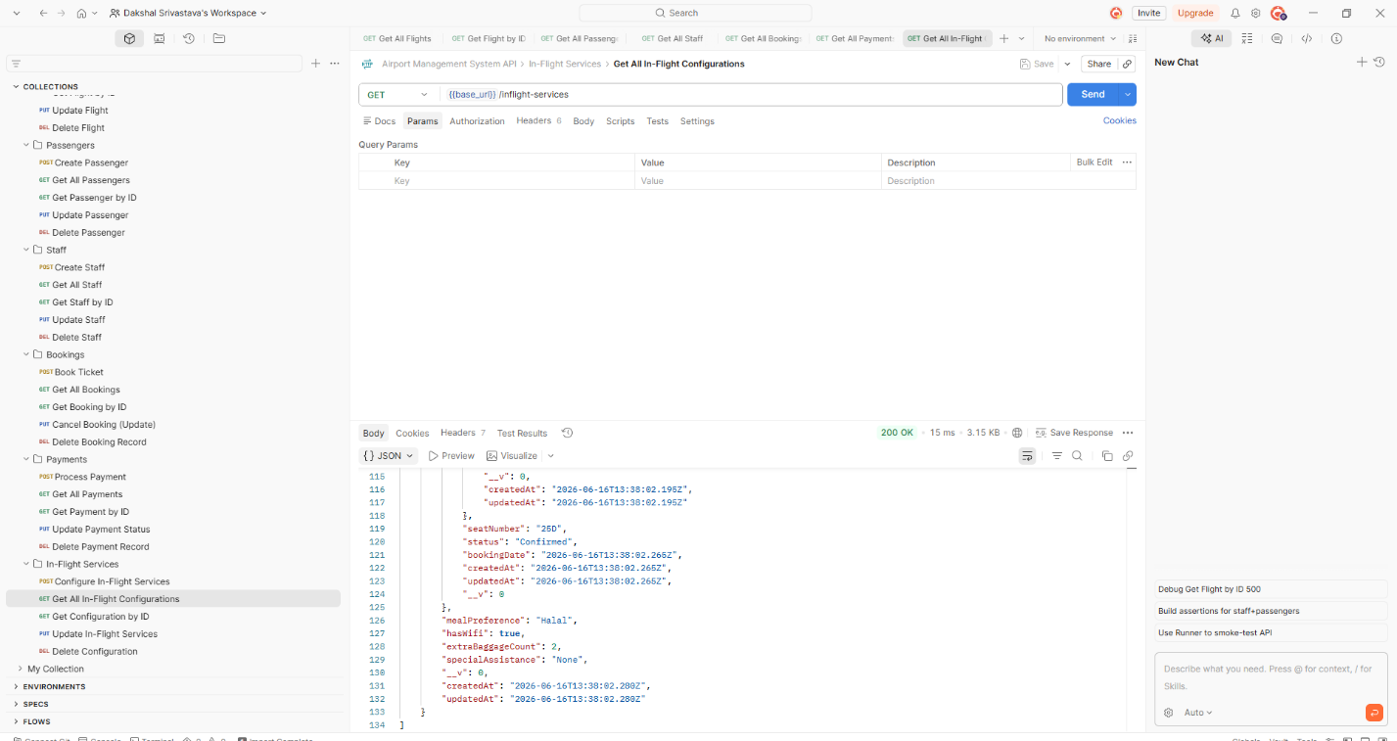
Postman – Flight Configurations
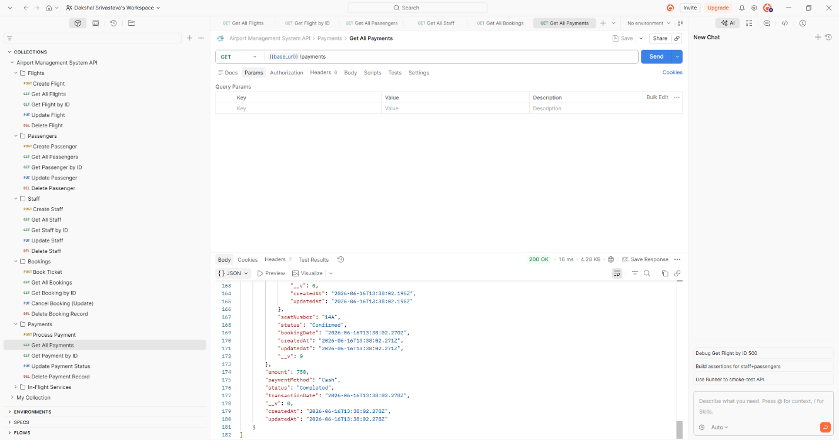
Postman - Payments
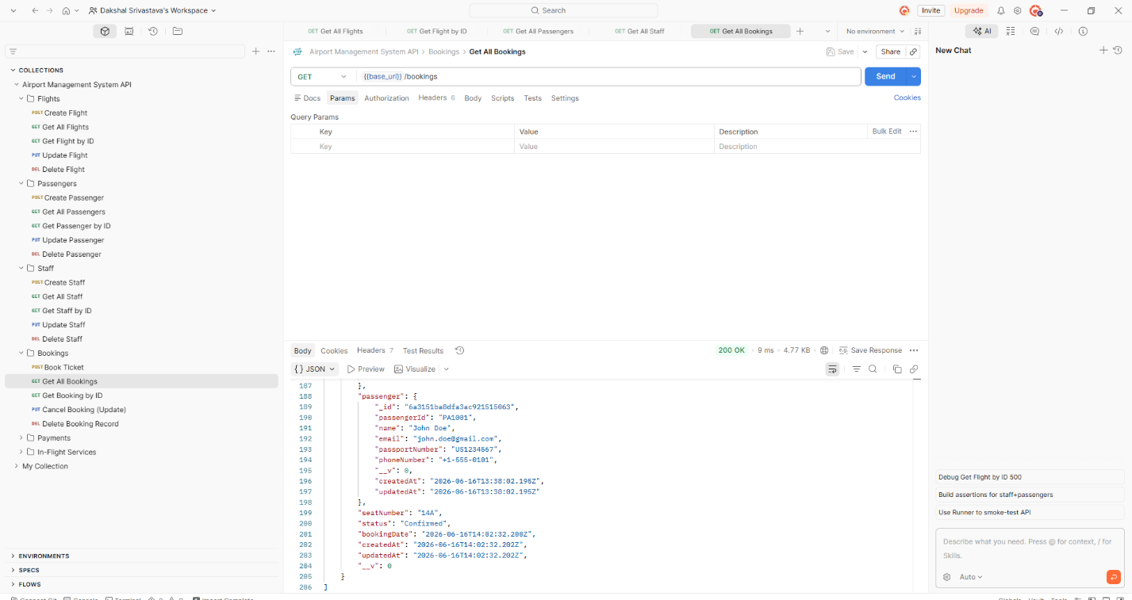
Postman - Bookings
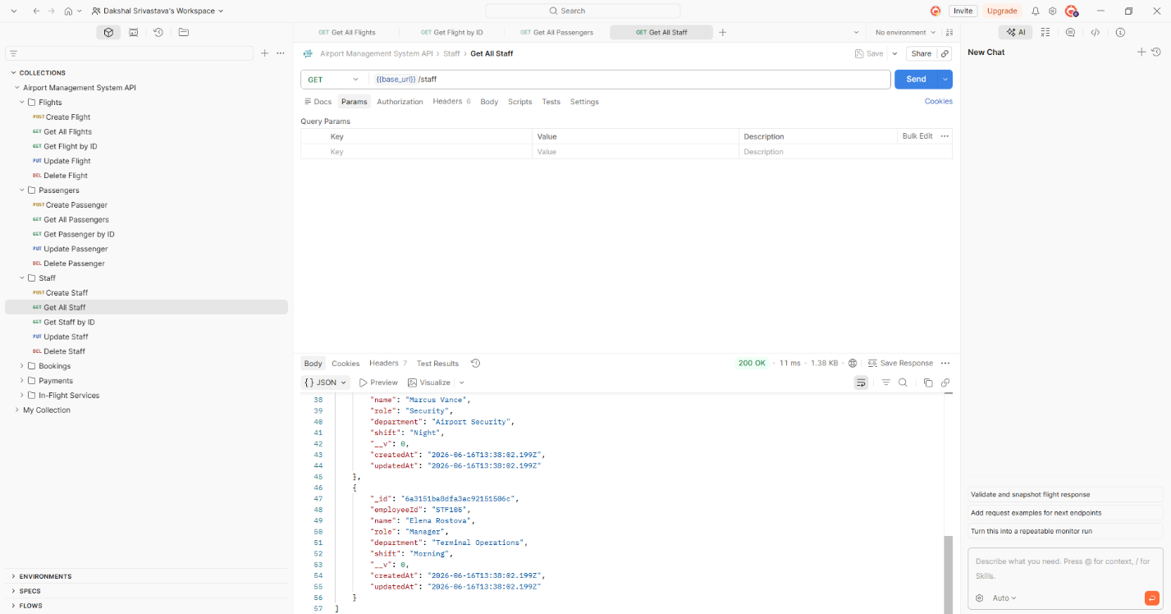
Postman – Staffs
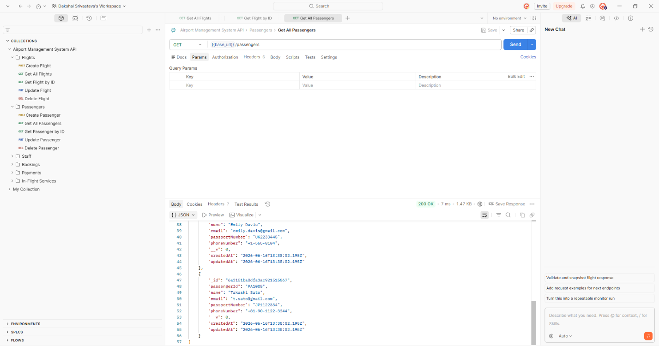
Postman - Passengers
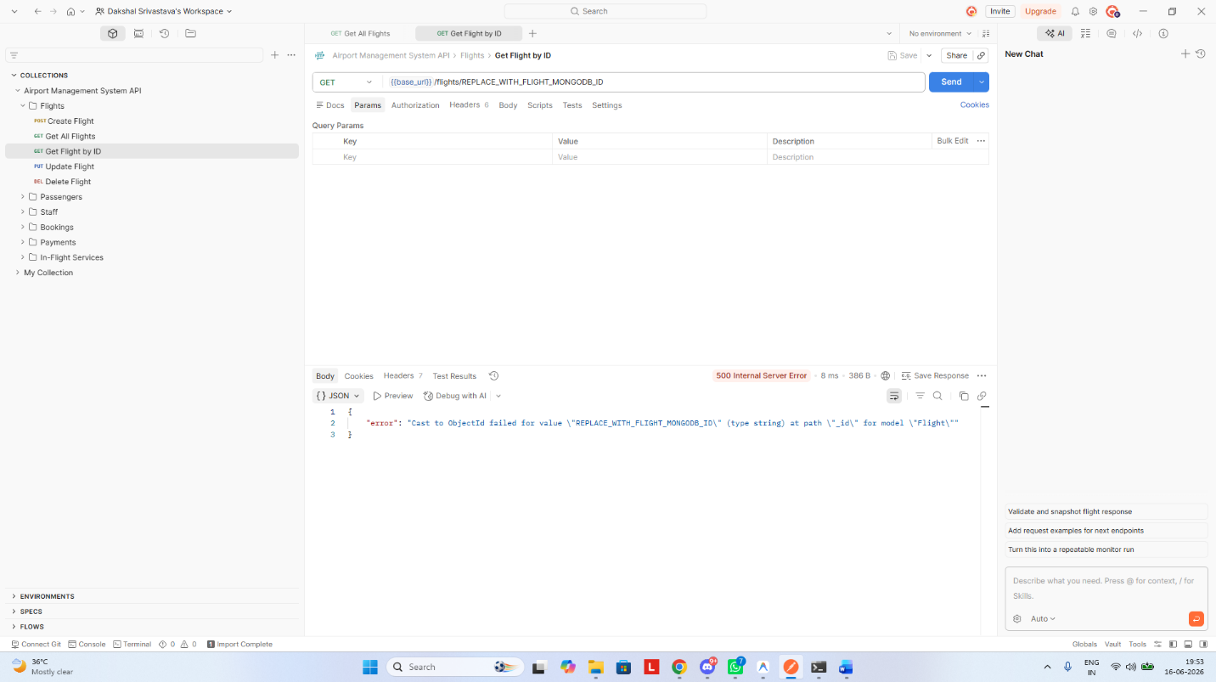
Postman - Flights

Database Schema Design
The system consists of six primary schemas.

1. Flight Schema
The Flight schema stores information regarding scheduled flights.

Key Fields
Field | Description
flightNumber | Unique flight identifier
origin | Departure location
destination | Arrival location
departureTime | Flight departure schedule
arrivalTime | Flight arrival schedule
ticketPrice | Cost of ticket
availableSeats | Number of available seats

Purpose
Provides route management and serves as the central entity for booking operations.

2. Passenger Schema
Stores passenger information and validates user identity.

Key Fields
Field | Description
fullName | Passenger name
email | Unique email address
phone | Contact number
passportNumber | Passport identification

Validation Rules
- Unique email enforcement.
- Passport format validation.
- Mandatory personal details.

Purpose
Maintains passenger registry and prevents duplicate records.

3. Staff Schema
Stores airport personnel information.

Key Fields
Field | Description
name | Staff member name
role | Job designation
department | Assigned department
shift | Working shift
contact | Communication details

Departments Supported
- Pilots
- Cabin Crew
- Security
- Administration
- Management

Purpose
Supports workforce management and operational coordination.

4. Booking Schema
Acts as a junction between passengers and flights.

Key Fields
Field | Description
passengerId | Reference to Passenger
flightId | Reference to Flight
bookingDate | Date of booking
status | Confirmed / Cancelled

Relationships
Passenger
│
│
▼
Booking
▲
│
│
Flight

Purpose
Tracks ticket reservations and seat allocation.

5. Payment Schema
Stores payment and invoice details.

Key Fields
Field | Description
bookingId | Associated booking
amount | Ticket amount
paymentMethod | Payment type
paymentStatus | Completed/Pending

Purpose
Maintains financial records and automates invoice generation.

6. In-Flight Service Schema
Stores passenger customization preferences.

Key Fields
Field | Description
bookingId | Associated booking
mealPreference | Meal selection
wifiRequired | Wi-Fi requirement
extraLuggage | Additional baggage
specialAssistance | Accessibility support

Purpose
Allows passengers to personalize travel experience.

Entity Relationships
Passenger
│
│ 1:N
▼
Booking
│
│ N:1
▼
Flight
Booking
│
│ 1:1
▼
Payment
Booking
│
│ 1:1
▼
InFlight Service

Key Implementation Logic

1. Automatic Seat Allocation Trigger
When a booking is created and confirmed:
- Passenger selects a flight.
- System verifies seat availability.
- Booking record is generated.
- Available seat count is reduced by one.

Process
Create Booking
│
▼
Check Available Seats
│
▼
Booking Confirmed
│
▼
Seats = Seats - 1

Benefits
- Prevents overbooking.
- Maintains real-time seat inventory.
- Ensures booking consistency.

2. Automatic Seat Restoration Trigger
When a booking is deleted or cancelled:
- Booking status changes to “Cancelled” OR
- Booking record is removed.
The system automatically restores the seat.

Process
Cancel Booking
│
▼
Restore Seat
│
▼
Seats = Seats + 1

Benefits
- Prevents seat loss.
- Keeps inventory synchronized.
- Supports booking modifications.

3. Payment Auto-Pricing Logic
The payment module includes automated invoice generation.

Workflow
- User creates payment.
- Amount field is optional.
- System checks if amount is provided.
- If blank:
  - Retrieve associated booking.
  - Retrieve linked flight.
  - Read ticket price.
  - Populate payment amount automatically.

Process
Create Payment
│
▼
Amount Empty?
/ \
Yes No
│ │
▼ ▼
Fetch Flight Price
│
▼
Assign Amount

Benefits
- Eliminates manual pricing errors.
- Maintains billing accuracy.
- Improves automation.

4. One-to-One In-Flight Service Rule
Each booking may have only one customization record.

Validation Logic
Before creating a service entry:
- System searches for existing service linked to booking.
- If found:
  - Reject insertion.
- If not found:
  - Create customization record.

Rule
1 Booking → Maximum 1 Service Sheet

Benefits
- Prevents duplicate preferences.
- Maintains clean data relationships.
- Simplifies service management.

Tools & Versions Used
Technology | Version | Purpose
Node.js | v18+ | Runtime Environment
Express.js | v5.2.1 | Backend Framework
MongoDB | Latest Stable | Database
Mongoose | v9.7.0 | ODM and Schema Modeling
Swagger UI Express | v5.0.1 | API Documentation
Swagger JSDoc | v6.3.0 | Swagger Specification Generation
Postman | Latest | API Testing
readline-sync | v1.4.10 | CLI User Input
dotenv | v16.4.5 | Environment Configuration

Conclusion
The Airport Management System successfully demonstrates the development of a modern backend application using Node.js, Express.js, MongoDB, and Mongoose. The project implements practical database relationships, validation mechanisms, automated triggers, and RESTful API architecture.
Advanced features such as automatic seat allocation, seat restoration, payment auto-pricing, and one-to-one service customization constraints significantly enhance data consistency and operational efficiency. The integration of Swagger UI and Postman ensures thorough API testing and documentation, while the interactive CLI provides an alternative user-friendly interface for system interaction.
Through this project, valuable experience was gained in backend development, schema design, REST API implementation, database management, validation techniques, and software testing methodologies. The project successfully meets its objectives and serves as a scalable foundation for future airport management solutions.

Submitted By
Dakshal Srivastava
Registration Number: 24BSA10115

